
CONSENT COMPLIANCE ASSESSMENT
BETA TEST RELEASE
https://www.independent.ie/
Test date: 2026-04-02
CMP: Didomi
13 FAIL · 15 PASS · 10 MANUAL
OVERALL RISK: HIGH

1. Executive Summary
Independent.ie demonstrates significant GDPR and ePrivacy compliance failures including pre-consent tracking, persistent tracking after reject-all, and dark pattern design requiring multiple clicks to decline. The consent banner lacks a direct reject option on the first layer and maintains tracker functionality even after users decline consent. Cookie consent state is not properly maintained across sessions, and numerous undeclared cookies are present. These violations expose the site to enforcement action under both GDPR Article 5-7 and ePrivacy Directive Article 5(3).

2. Consent State Screenshots
Captured automatically. Assessed by AI for K.1/K.2/K.3 UX compliance.

Layer 1 — Initial banner (before interaction)
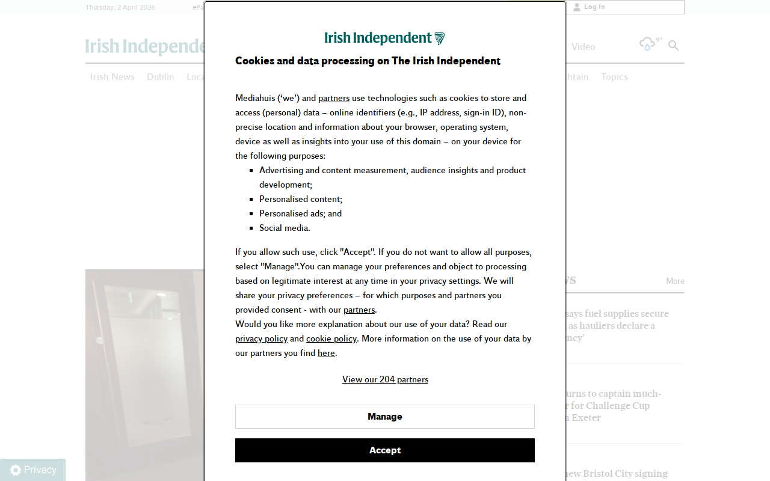
Layer 2 — After Accept All (consent baseline)

After Reject All (post-rejection state)
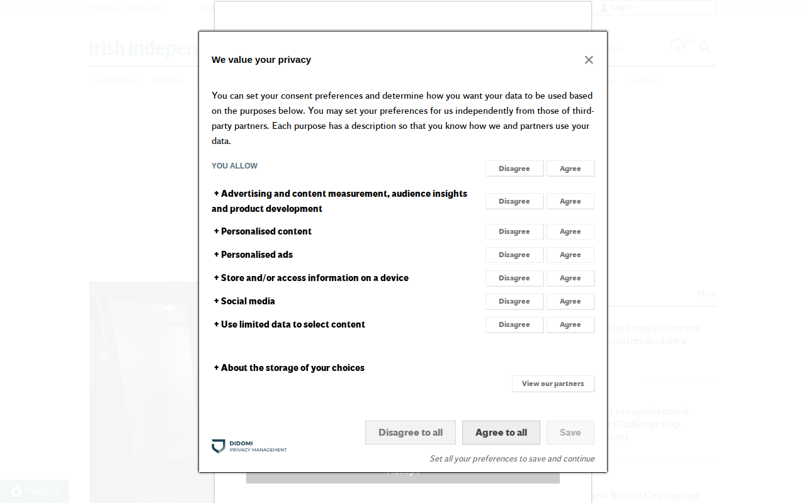

3. Methodology
Conducted using Waivern Consent Analyser (C1: HAR network analysis; C2: Playwright browser automation; C3: AI compliance analysis). Three phases: Accept All, Reject All, persistence check. Framework: ePrivacy Art. 5(3), GDPR Arts. 6/7/25, Datatilsynet guidance.

Parameter | Value
Target URL | https://www.independent.ie/
Test Date | 2026-04-02
Analysis Framework | HIGH risk
Probe Location | 🇳🇱 Amsterdam, North Holland, The Netherlands (208.77.244.106) — Railway
CMP Platform | Didomi
Accept Button | "Accept"
Reject Button | "" (1 clicks)

⚠️ Important: Results reflect how https://www.independent.ie/ presents to the probe location (Amsterdam, North Holland, The Netherlands (208.77.244.106) — Railway). Sites may show different consent controls to users in different jurisdictions (e.g. GDPR banners only to EU IPs; CCPA opt-out links only to California IPs). Re-run from a different location to test geo-specific behaviour.

4. Summary of Findings
Category | Result
Pre Consent Clean | FAIL
No Tracking Cookies Pre Consent | PASS
Tracker Globals Undefined | FAIL
No Tracking Storage Pre Consent | PASS
Network Blocked After Decline | MANUAL
Third Party Cookies Absent | MANUAL
Doc Cookie Clean Post Reject | PASS
Web Storage Clean Post Reject | PASS
First Party Cookies Classified | INFO
Server Side Cookies Gated | NOT_RUN
No Cname Cloaking | PASS
Tracker Globals Absent | FAIL
Dom Scripts Blocked | FAIL
Reject Equals Accept Clicks | PASS
No Preticked Boxes | MANUAL
Persistent Withdrawal Widget | PASS
No Cookie Wall | PASS
Consent Persists | FAIL

5. Detailed Findings

5.1 High Risk
B.1 No tracking requests before consent banner interaction
2 tracking domain(s) made requests before any consent signal was recorded.
Regulatory basis: ePrivacy Directive Art. 5(3) · GDPR Art. 6(1)(a)
Precedent: EDPB Guidelines 2/2023 confirm analytics and tracking require prior consent regardless of first/third-party distinction.
Remediation: Block all tracking requests until explicit consent is obtained through technical implementation in the CMP.

B.3 JS tracker globals return undefined pre-consent
Tracker globals defined before consent: ['google_tag_manager']
Regulatory basis: GDPR Art. 25 · ePrivacy Directive Art. 5(3)
Precedent: GDPR Article 25 requires data protection by design with non-processing as the default state.
Remediation: Defer all tracker initialization including GTM until after valid consent is received.

B.5 Non-essential scripts have type=text/plain (CMP-blocked) in DOM
2 tracking script(s) in DOM without CMP-blocking type attribute.
Regulatory basis: GDPR Art. 25 · ePrivacy Directive Art. 5(3)
Precedent: Technical measures must prevent processing by default under GDPR Article 25 data protection by design.
Remediation: Implement type='text/plain' blocking for all non-essential scripts until consent is granted.

E.4 No tracking activity on subpages after reject-all
Tracking activity detected on 2 subpage(s) after reject.
Regulatory basis: GDPR Art. 7(3) · ePrivacy Directive Art. 5(3)
Precedent: GDPR Article 7(3) requires processing to cease immediately when consent is withdrawn.
Remediation: Ensure all tracking ceases immediately upon consent withdrawal across all site pages.

H.1 Tracker JS globals (ga, gtag, fbq, hj, etc.) return undefined post-reject
Tracker globals still defined after reject-all: ['google_tag_manager']
Regulatory basis: GDPR Art. 7(3) · ePrivacy Directive Art. 5(3)
Precedent: Processing must cease immediately upon consent withdrawal per GDPR Article 7(3).
Remediation: Properly disable all tracker globals including GTM when consent is declined or withdrawn.

H.3 window.dataLayer absent or contains no tracking events post-reject
dataLayer contains 3 tracking event(s): ['gtm.js', 'gtm.dom', 'pageview']
Regulatory basis: GDPR Art. 7(3) · ePrivacy Directive Art. 5(3)
Precedent: Continued processing after rejection violates both ePrivacy prior consent and GDPR withdrawal rights.
Remediation: Clear dataLayer of tracking events and prevent new events when consent is declined.

I.1 Tracker script tags have type=text/plain (CMP-blocked) in DOM post-reject
2 tracker script(s) in DOM without CMP type-blocking post-reject. 0 script(s) correctly blocked.

I.2 Non-essential scripts blocked (type=text/plain)
See I.1 — same check.

I.3 No tracker JS files in executed sources post-reject
Based on DOM script inventory; full Sources tab verification requires Chrome DevTools protocol introspection (beyond current scope).

K.1 Reject All at same prominence and level as Accept All
Reject All not directly accessible from first consent screen — requires entering Manage Preferences. EDPB guidelines require equal prominence.
Regulatory basis: GDPR Art. 7 · EDPB Guidelines 05/2020
Precedent: EDPB Cookie Banner Taskforce Report (Jan 2023) requires reject button as prominent as accept; CNIL fined Google/Facebook for requiring more clicks to reject.
Remediation: Provide equally prominent Reject All button on first consent layer alongside Accept All.

K.3 No dark patterns in consent banner (colour, visual hierarchy)
Multiple dark patterns present: 1) No reject all button on first layer forcing users into manage panel, 2) Accept button has strong visual prominence with black styling while alternative (Manage) is grey, 3) Rejection requires navigating through additional interface layers while acceptance is immediate.
Regulatory basis: GDPR Art. 6(1)(a) · GDPR Art. 7
Precedent: CJEU Orange România (C-61/19) requires genuinely free consent without deceptive design elements.
Remediation: Redesign consent interface with equal visual prominence for accept/reject options and symmetric navigation.

L.3 Declined state maintained after closing and reopening (simulate new session)
Advertising cookies found on return — consent state not correctly maintained.
Regulatory basis: GDPR Art. 7(3) · ePrivacy Directive Art. 5(3)
Precedent: Users should not be repeatedly asked for the same consent per EDPB Guidelines 05/2020.
Remediation: Fix consent persistence mechanism to maintain rejection state across browser sessions.

5.2 Medium Risk
G.2 All observed cookies declared in cookie policy
47 cookie(s) observed but not found in cookie policy at https://www.mediahuis.ie/cookiepolicy.
Regulatory basis: GDPR Art. 5(1)(a) · GDPR Art. 13
Precedent: GDPR Article 5(1)(a) requires transparent processing with complete information provision.
Remediation: Update cookie policy to accurately declare all cookies with purposes and legal bases.

L.2 Consent choice respected on second tab (same session)
Advertising cookies found in second tab — consent state may not be persisted.
Regulatory basis: GDPR Art. 7(3) · ePrivacy Directive Art. 5(3)
Precedent: Consent withdrawal must be effective across the entire service per GDPR Article 7(3).
Remediation: Implement proper consent state persistence across all browser tabs and windows.

6. Cookie Inventory
Name | Domain | Expires | Category | Necessary | Declared
X-AB | sc-static.net | 1.0d | UNKNOWN
__cf_bm | .independent.ie | 0.0d | ESSENTIAL
gig_canary | cdns.gigya.com | 0.0d | UNKNOWN
fp.browser_session_id | .independent.ie | sessiond | ESSENTIAL
gig_canary | cdns.eu1.gigya.com | 0.0d | UNKNOWN
gmid | .gigya-cp.independent.ie | 365.0d | UNKNOWN
ucid | .gigya-cp.independent.ie | 365.0d | UNKNOWN
hasGmid | .gigya-cp.independent.ie | 183.0d | UNKNOWN
gig_bootstrap_4_CO8231Ix1RbYi2EmMbsrlw | .independent.ie | 365.0d | UNKNOWN
sc | www.independent.ie | 0.0d | UNKNOWN
_mhtc_cId | .independent.ie | 31.0d | UNKNOWN
didomi_token | .independent.ie | 366.0d | ESSENTIAL
euconsent-v2 | .independent.ie | 366.0d | ESSENTIAL
_gcl_au | .independent.ie | 90.0d | UNKNOWN
sessionId | www.independent.ie | 0.0d | ESSENTIAL
viewSq | www.independent.ie | 0.0d | UNKNOWN
_mhtrdisableshortname | www.independent.ie | 0.0d | UNKNOWN
_ttp | .tiktok.com | 90.0d | UNKNOWN
uid | .criteo.com | 390.0d | UNKNOWN
_twpid | .independent.ie | 390.0d | UNKNOWN
_rdt_uuid | .independent.ie | 90.0d | UNKNOWN
muc_ads | .t.co | 400.0d | UNKNOWN
IDE | .doubleclick.net | 390.0d | AD
_scid | .independent.ie | 395.0d | UNKNOWN
_scid_r | .independent.ie | 395.0d | UNKNOWN
guest_id_marketing | .twitter.com | 400.0d | UNKNOWN
guest_id_ads | .twitter.com | 400.0d | UNKNOWN
personalization_id | .twitter.com | 400.0d | UNKNOWN
guest_id | .twitter.com | 400.0d | UNKNOWN
sc_at | .snapchat.com | 390.0d | UNKNOWN
test_cookie | .doubleclick.net | 0.0d | UNKNOWN
bcookie | .linkedin.com | 365.0d | UNKNOWN
li_gc | .linkedin.com | 180.0d | UNKNOWN
lidc | .linkedin.com | 1.0d | UNKNOWN
_ga | .independent.ie | 400.0d | AD
cto_bundle | .criteo.com | 390.0d | UNKNOWN
_mhtc_sId | .independent.ie | 0.0d | UNKNOWN
_hjSessionUser_1713171 | .independent.ie | 365.0d | ESSENTIAL
_hjSession_1713171 | .independent.ie | 0.0d | ESSENTIAL
_fbp | .independent.ie | 90.0d | AD
_tt_enable_cookie | .independent.ie | 90.0d | UNKNOWN
_ttp | .independent.ie | 90.0d | UNKNOWN
__gads | .independent.ie | 390.0d | AD
__gpi | .independent.ie | 390.0d | AD
__eoi | .independent.ie | 180.0d | AD
cto_bundle | .independent.ie | 390.0d | UNKNOWN
_ga_W2EK8THFQJ | .independent.ie | 400.0d | AD
ttcsid | .independent.ie | 90.0d | UNKNOWN
ttcsid_CSN1O63C77U450RMS5E0 | .independent.ie | 90.0d | UNKNOWN
DSID | .doubleclick.net | 0.0d | AD
_ain_cid | www.independent.ie | 0.0d | UNKNOWN
_ain_uid | www.independent.ie | 180.0d | UNKNOWN

7. Third-Party Tracker Inventory
No post-reject tracker data available.

8. Remediation Roadmap
- Implement technical blocking of all tracking until consent with proper CMP script blocking
Effort: high | Impact: Prevents pre-consent violations and ensures compliance with ePrivacy Directive requirements
- Redesign consent banner with prominent Reject All button on first layer
Effort: medium | Impact: Eliminates dark patterns and ensures freely given consent under GDPR Article 7
- Fix consent state persistence to properly maintain rejection across sessions and tabs
Effort: medium | Impact: Ensures consent withdrawal is respected and prevents unauthorized tracking resumption
- Update cookie policy to declare all 47 observed cookies with purposes and legal bases
Effort: low | Impact: Improves transparency and reduces risk of information violations under GDPR Article 13
- Implement comprehensive post-rejection cleanup to disable all tracking functionality
Effort: medium | Impact: Ensures complete cessation of processing upon consent withdrawal as required by GDPR Article 7(3)

9. Regulatory References
ePrivacy Directive 2002/58/EC Art. 5(3) — terminal device consent requirement.
Norwegian ekomloven para 2-7b — national implementation of ePrivacy Directive.
GDPR (EU) 2016/679 Arts. 5, 6, 7, 25 — lawfulness, consent, withdrawal, privacy by design.
CJEU Planet49 C-673/17 (2019) — pre-ticked boxes invalid; consent must precede processing.
EDPB Guidelines 05/2020 on consent — freely given, as easy to withdraw as give.
EDPB Cookie Banner Taskforce Report (Jan 2023) — reject prominence, dark patterns.
CNIL decisions (Dec 2021) — reject requiring more clicks = GDPR breach.
Datatilsynet, Grindr decision (2022-2023) — RTB without valid consent, NOK 65M fine.
IAB TCF 2.2 Policy (2023) — bid request initiation is itself a processing activity.

Disclaimer
This report is produced by the Waivern Consent Analyser, a product of Waivern Limited. It is provided for informational purposes only and does not constitute legal advice, regulatory guidance, or professional compliance consulting.

No warranty of accuracy or completeness: While Waivern endeavours to maintain accuracy, no representations or warranties, express or implied, are made regarding the accuracy, completeness, reliability, or suitability of any information in this report. Automated analysis may produce false positives or false negatives.

Limitations: This tool analyses websites from a single geographic location at a specific point in time. Results may vary based on network conditions, website configuration changes, A/B testing, bot detection, and other factors.

AI-generated content: AI-enhanced sections of this report are generated using third-party artificial intelligence services. AI outputs including regulatory citations, risk assessments, and remediation recommendations may contain inaccuracies or outdated information and should be independently verified.

Limitation of liability: To the fullest extent permitted by law, Waivern Limited shall not be liable for any direct, indirect, incidental, special, consequential, or punitive damages arising from use of this report.

You should consult qualified legal counsel familiar with your specific circumstances before taking any action based on the findings in this report.

Generated by Waivern Consent Analyser.
© Waivern Limited. All rights reserved.

