
CONSENT COMPLIANCE ASSESSMENT
BETA TEST RELEASE
https://www.waivern.com
Test date: 2026-04-08
CMP: Cookiebot
9 FAIL · 25 PASS · 5 MANUAL
OVERALL RISK: HIGH

1. Executive Summary
The website shows significant GDPR compliance violations with tracking occurring both before consent and continuing after consent rejection. Google Analytics and Tag Manager remain active throughout the user journey regardless of consent choices. The absence of a persistent consent withdrawal mechanism further compounds compliance issues. These findings indicate systematic non-compliance with EU data protection requirements rather than implementation of any recognised alternative compliance model.

2. Consent State Screenshots
Captured automatically. Assessed by AI for K.1/K.2/K.3 UX compliance.

Layer 1 — Initial banner (before interaction)
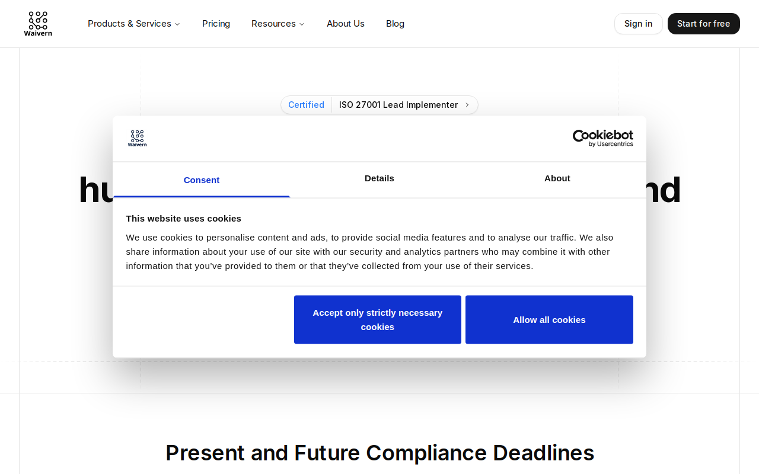
Layer 2 — After Accept All (consent baseline)

After Reject All (post-rejection state)

3. Methodology
Conducted using Waivern Consent Analyser (C1: HAR network analysis; C2: Playwright browser automation; C3: AI compliance analysis). Three phases: Accept All, Reject All, persistence check. Framework: ePrivacy Art. 5(3), GDPR Arts. 6/7/25, Datatilsynet guidance.

Parameter | Value
Target URL | https://www.waivern.com
Test Date | 2026-04-08
Analysis Framework | HIGH risk
Probe Location | 🇳🇱 Amsterdam, North Holland, The Netherlands (208.77.244.106) — Railway
CMP Platform | Cookiebot
Accept Button | "Allow all cookies"
Reject Button | "Accept only strictly necessary cookies" (1 clicks)

⚠️ Important: Results reflect how https://www.waivern.com presents to the probe location (Amsterdam, North Holland, The Netherlands (208.77.244.106) — Railway). Sites may show different consent controls to users in different jurisdictions (e.g. GDPR banners only to EU IPs; CCPA opt-out links only to California IPs). Re-run from a different location to test geo-specific behaviour.

4. Summary of Findings
Category | Result
Pre Consent Clean | FAIL
No Tracking Cookies Pre Consent | PASS
Tracker Globals Undefined | FAIL
No Tracking Storage Pre Consent | PASS
Network Blocked After Decline | FAIL
Third Party Cookies Absent | PARTIAL
Doc Cookie Clean Post Reject | PASS
Web Storage Clean Post Reject | PASS
First Party Cookies Classified | INFO
Server Side Cookies Gated | PASS
No Cname Cloaking | MANUAL
Tracker Globals Absent | FAIL
Dom Scripts Blocked | PASS
Reject Equals Accept Clicks | PASS
No Preticked Boxes | MANUAL
Persistent Withdrawal Widget | FAIL
No Cookie Wall | PASS
Consent Persists | PASS

5. Detailed Findings

5.1 High Risk
B.1 No tracking requests before consent banner interaction
1 tracking domain(s) made requests before any consent signal was recorded.
Regulatory basis: ePrivacy Directive Art. 5(3) · GDPR Art. 6(1)(a)
Precedent: EDPB Guidelines 2/2023 confirm that analytics tracking requires prior consent regardless of first/third-party distinction.
Remediation: Implement strict technical measures to prevent any tracking domain requests until explicit user consent is obtained through banner interaction.

B.3 JS tracker globals return undefined pre-consent
Tracker globals defined before consent: ['gtag', 'google_tag_manager']
Regulatory basis: ePrivacy Directive Art. 5(3) · GDPR Art. 25
Precedent: GDPR Art. 25 requires data protection by design with non-processing as the default state before consent.
Remediation: Configure Google Tag Manager and gtag to load only after affirmative consent, implementing data protection by design principles.

E.1 No requests to non-essential third-party domains after reject-all
1 tracking domain(s) continued firing after reject-all.
Regulatory basis: GDPR Art. 7(3) · ePrivacy Directive Art. 5(3)
Precedent: GDPR Art. 7(3) mandates that data processing must cease immediately upon consent withdrawal.
Remediation: Ensure all non-essential tracking domains cease operations immediately upon consent withdrawal as required by GDPR Article 7(3).

E.3 No tracking pixels or beacons fired after reject-all
2 tracking pixel/beacon call(s) post-reject.
Regulatory basis: ePrivacy Directive Art. 5(3) · GDPR Art. 7(3)
Precedent: EDPB Guidelines 05/2020 specify that consent withdrawal must result in immediate cessation of all related processing.
Remediation: Block all tracking pixels and beacon calls when users reject consent to ensure compliance with withdrawal requirements.

E.4 No tracking activity on subpages after reject-all
Tracking activity detected on 2 subpage(s) after reject.
Regulatory basis: GDPR Art. 7(3) · GDPR Art. 5(1)(a)
Precedent: CJEU Planet49 established that consent scope must be respected across the entire user journey.
Remediation: Implement site-wide consent state management to prevent tracking across all pages after consent rejection.

H.1 Tracker JS globals (ga, gtag, fbq, hj, etc.) return undefined post-reject
Tracker globals still defined after reject-all: ['gtag', 'google_tag_manager']
Regulatory basis: GDPR Art. 7(3) · ePrivacy Directive Art. 5(3)
Precedent: EDPB Guidelines 05/2020 require that consent withdrawal must be technically effective, not merely cosmetic.
Remediation: Configure technical implementation to undefine or disable gtag and google_tag_manager globals when consent is withdrawn.

K.5 Persistent consent withdrawal mechanism accessible after interaction
No persistent consent widget found. Users cannot easily withdraw consent.
Regulatory basis: GDPR Art. 7(3) · EDPB Guidelines 05/2020
Precedent: EDPB Guidelines 05/2020 mandate that withdrawal must be as easy as giving consent, requiring persistent access mechanisms.
Remediation: Implement a persistent, easily accessible consent management widget allowing users to modify or withdraw consent at any time.

5.2 Medium Risk
H.3 window.dataLayer absent or contains no tracking events post-reject
dataLayer contains 1 tracking event(s): ['gtm.dom']
Regulatory basis: GDPR Art. 7(3) · GDPR Art. 5(1)(e)
Precedent: GDPR storage limitation principle requires that tracking data collection cease when legal basis is withdrawn.
Remediation: Clear or prevent population of dataLayer with tracking events like 'gtm.dom' when consent is rejected.

6. Cookie Inventory
Name | Domain | Expires | Category | Necessary | Declared
CookieConsent | www.waivern.com | 365.0d | ESSENTIAL

7. Third-Party Tracker Inventory
Domain | Vendor | Category | Requests
region1.google-analytics.com | Google Analytics | ANALYTICS | 2

8. Remediation Roadmap
- Implement technical blocking of all tracking before consent banner interaction
Effort: high | Impact: Prevents pre-consent violations and establishes compliant baseline state
- Configure complete tracking cessation upon consent rejection across all pages
Effort: high | Impact: Ensures consent withdrawal is technically effective site-wide
- Deploy persistent consent management widget accessible from all pages
Effort: medium | Impact: Provides required ongoing consent control mechanism for users
- Clean dataLayer management to prevent tracking events post-rejection
Effort: low | Impact: Eliminates residual tracking artifacts after consent withdrawal
- Conduct comprehensive testing across user journeys and subpages
Effort: medium | Impact: Validates technical implementation effectiveness across entire site

9. Regulatory References
ePrivacy Directive 2002/58/EC Art. 5(3) — terminal device consent requirement.
Norwegian ekomloven para 2-7b — national implementation of ePrivacy Directive.
GDPR (EU) 2016/679 Arts. 5, 6, 7, 25 — lawfulness, consent, withdrawal, privacy by design.
CJEU Planet49 C-673/17 (2019) — pre-ticked boxes invalid; consent must precede processing.
EDPB Guidelines 05/2020 on consent — freely given, as easy to withdraw as give.
EDPB Cookie Banner Taskforce Report (Jan 2023) — reject prominence, dark patterns.
CNIL decisions (Dec 2021) — reject requiring more clicks = GDPR breach.
Datatilsynet, Grindr decision (2022-2023) — RTB without valid consent, NOK 65M fine.
IAB TCF 2.2 Policy (2023) — bid request initiation is itself a processing activity.

Disclaimer
This report is produced by the Waivern Consent Analyser, a product of Waivern Limited. It is provided for informational purposes only and does not constitute legal advice, regulatory guidance, or professional compliance consulting.

No warranty of accuracy or completeness: While Waivern endeavours to maintain accuracy, no representations or warranties, express or implied, are made regarding the accuracy, completeness, reliability, or suitability of any information in this report. Automated analysis may produce false positives or false negatives.

Limitations: This tool analyses websites from a single geographic location at a specific point in time. Results may vary based on network conditions, website configuration changes, A/B testing, bot detection, and other factors.

AI-generated content: AI-enhanced sections of this report are generated using third-party artificial intelligence services. AI outputs including regulatory citations, risk assessments, and remediation recommendations may contain inaccuracies or outdated information and should be independently verified.

Limitation of liability: To the fullest extent permitted by law, Waivern Limited shall not be liable for any direct, indirect, incidental, special, consequential, or punitive damages arising from use of this report.

You should consult qualified legal counsel familiar with your specific circumstances before taking any action based on the findings in this report.

Generated by Waivern Consent Analyser.
© Waivern Limited. All rights reserved.

