
CONSENT COMPLIANCE ASSESSMENT
BETA TEST RELEASE
https://www.ebay.co.uk
Test date: 2026-04-01
CMP: Unknown / Not detected
4 FAIL · 31 PASS · 4 MANUAL
OVERALL RISK: HIGH

1. Executive Summary
eBay UK demonstrates significant GDPR and ePrivacy compliance violations, particularly around cookie consent management. The site sets 68 non-essential cookies after users reject tracking, directly violating ePrivacy Directive requirements for prior consent. Additionally, 12 cookies are deployed without proper disclosure in the privacy policy, creating transparency issues under GDPR Article 5(1)(a). While consent preferences are correctly persisted across browser sessions, the fundamental failure to respect user rejection choices presents high enforcement risk under both GDPR and UK PECR.

2. Consent State Screenshots
Captured automatically. Assessed by AI for K.1/K.2/K.3 UX compliance.

Layer 1 — Initial banner (before interaction)

Layer 2 — After Accept All (consent baseline)
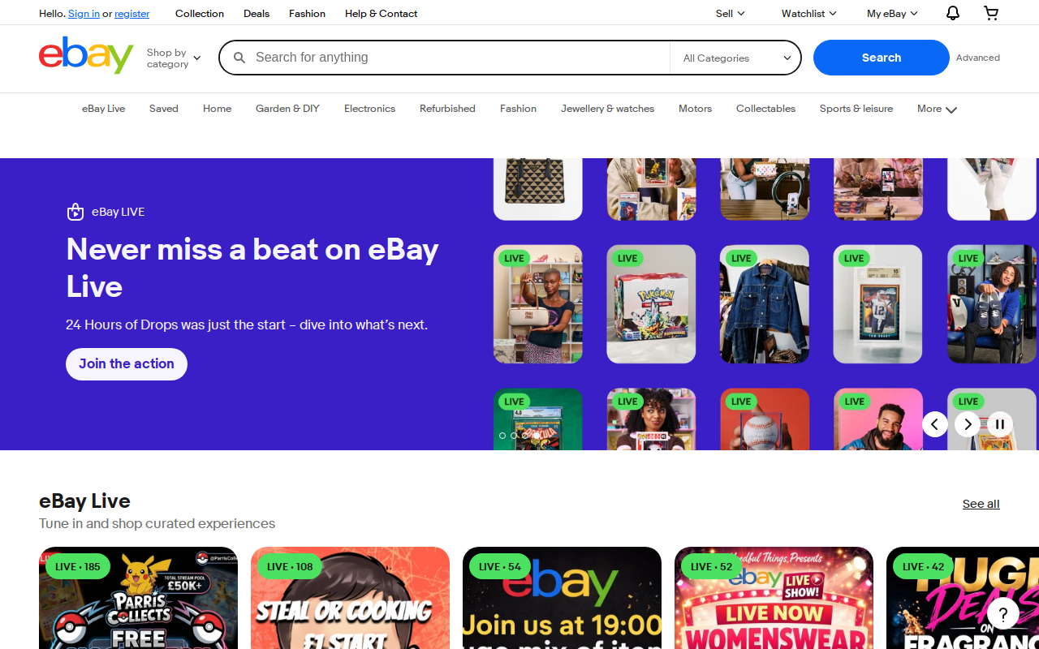
After Reject All (post-rejection state)
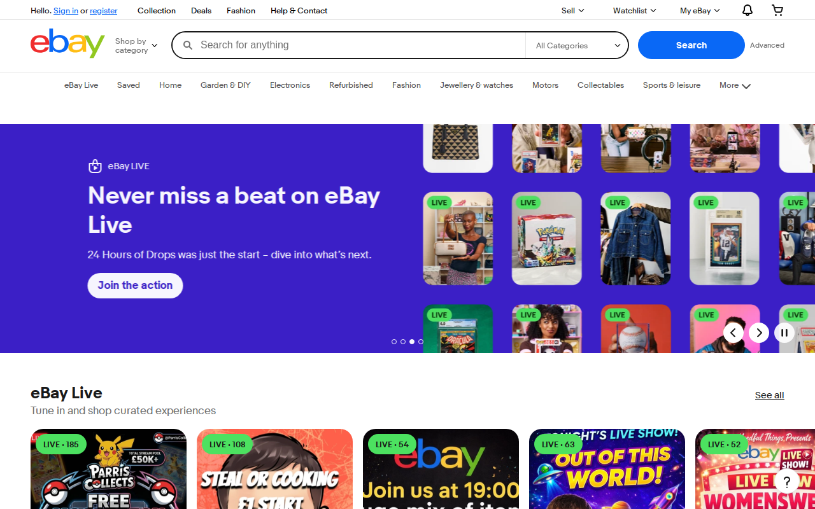

3. Methodology
Conducted using Waivern Consent Analyser (C1: HAR network analysis; C2: Playwright browser automation; C3: AI compliance analysis). Three phases: Accept All, Reject All, persistence check. Framework: ePrivacy Art. 5(3), GDPR Arts. 6/7/25, Datatilsynet guidance.

Parameter | Value
Target URL | https://www.ebay.co.uk
Test Date | 2026-04-01
Analysis Framework | HIGH risk
Probe Location | 🇳🇱 Amsterdam, North Holland, The Netherlands (208.77.244.106) — Railway
CMP Platform | Unknown / Not detected
Accept Button | "Accept all"
Reject Button | "Decline all" (1 clicks)

⚠️ Important: Results reflect how https://www.ebay.co.uk presents to the probe location (Amsterdam, North Holland, The Netherlands (208.77.244.106) — Railway). Sites may show different consent controls to users in different jurisdictions (e.g. GDPR banners only to EU IPs; CCPA opt-out links only to California IPs). Re-run from a different location to test geo-specific behaviour.

4. Summary of Findings
Category | Result
Pre Consent Clean | PASS
No Tracking Cookies Pre Consent | PASS
Tracker Globals Undefined | PASS
No Tracking Storage Pre Consent | PASS
Network Blocked After Decline | PASS
Third Party Cookies Absent | PARTIAL
Doc Cookie Clean Post Reject | PASS
Web Storage Clean Post Reject | PASS
First Party Cookies Classified | INFO
Server Side Cookies Gated | FAIL
No Cname Cloaking | PASS
Tracker Globals Absent | PASS
Dom Scripts Blocked | PASS
Reject Equals Accept Clicks | PASS
No Preticked Boxes | MANUAL
Persistent Withdrawal Widget | PASS
No Cookie Wall | PASS
Consent Persists | PASS

5. Detailed Findings

5.1 High Risk
G.2 All observed cookies declared in cookie policy
12 cookie(s) observed but not found in cookie policy at https://www.ebay.co.uk/help/privacy.

G.7 No non-essential Set-Cookie headers after reject-all
68 Set-Cookie header(s) for non-essential cookies observed post-reject.
Regulatory basis: ePrivacy Directive Art. 5(3) · GDPR Art. 6(1)(a) · GDPR Art. 7(3)
Precedent: CNIL imposed €90M fine on Google for setting advertising cookies before consent and making withdrawal difficult, establishing cross-border enforcement precedent via EDPB consistency mechanism.
Remediation: Implement technical controls to immediately cease all non-essential cookie setting when users reject tracking consent, ensuring only strictly necessary cookies for core e-commerce functionality remain active.

L.2 Consent choice respected on second tab (same session)
Consent preference correctly persisted to second tab.

6. Cookie Inventory
Name | Domain | Expires | Category | Necessary | Declared
s | .ebay.co.uk | sessiond | UNKNOWN
__uzma | .ebay.co.uk | 180.0d | UNKNOWN
__uzmb | .ebay.co.uk | 180.0d | UNKNOWN
__uzmc | .ebay.co.uk | 180.0d | UNKNOWN
__uzmd | .ebay.co.uk | 180.0d | UNKNOWN
__uzme | .ebay.co.uk | 180.0d | UNKNOWN
__uzmf | .ebay.co.uk | 180.0d | UNKNOWN
ds2 | .ebay.com | sessiond | UNKNOWN
__deba | .ebay.co.uk | 180.0d | UNKNOWN
ds2 | .ebay.co.uk | sessiond | UNKNOWN
dp1 | .ebay.co.uk | 400.0d | UNKNOWN
ds2 | .ebay.co.uk | sessiond | UNKNOWN
nonsession | .ebay.co.uk | 400.0d | ESSENTIAL
ebay | .ebay.co.uk | sessiond | UNKNOWN

7. Third-Party Tracker Inventory
No post-reject tracker data available.

8. Remediation Roadmap
- Implement technical controls to stop all non-essential cookie setting immediately upon consent rejection
Effort: high | Impact: Eliminates highest-risk GDPR/ePrivacy violations and reduces immediate enforcement exposure
- Conduct comprehensive cookie audit and update privacy policy with complete cookie inventory
Effort: medium | Impact: Ensures transparency compliance and provides necessary documentation for regulatory inquiries
- Implement automated testing to verify consent choices are technically enforced across all cookie categories
Effort: medium | Impact: Provides ongoing assurance that user choices are respected and prevents regression
- Review and document legal basis for each cookie category, ensuring strict necessity exemptions are properly justified
Effort: low | Impact: Strengthens legal compliance position and prepares for potential regulatory scrutiny
- Establish regular compliance monitoring to ensure cookie practices remain aligned with evolving ICO and EDPB guidance
Effort: low | Impact: Maintains long-term compliance and adapts to regulatory developments

9. Regulatory References
ePrivacy Directive 2002/58/EC Art. 5(3) — terminal device consent requirement.
Norwegian ekomloven para 2-7b — national implementation of ePrivacy Directive.
GDPR (EU) 2016/679 Arts. 5, 6, 7, 25 — lawfulness, consent, withdrawal, privacy by design.
CJEU Planet49 C-673/17 (2019) — pre-ticked boxes invalid; consent must precede processing.
EDPB Guidelines 05/2020 on consent — freely given, as easy to withdraw as give.
EDPB Cookie Banner Taskforce Report (Jan 2023) — reject prominence, dark patterns.
CNIL decisions (Dec 2021) — reject requiring more clicks = GDPR breach.
Datatilsynet, Grindr decision (2022-2023) — RTB without valid consent, NOK 65M fine.
IAB TCF 2.2 Policy (2023) — bid request initiation is itself a processing activity.

Disclaimer
This report is produced by the Waivern Consent Analyser, a product of Waivern Limited. It is provided for informational purposes only and does not constitute legal advice, regulatory guidance, or professional compliance consulting.

No warranty of accuracy or completeness: While Waivern endeavours to maintain accuracy, no representations or warranties, express or implied, are made regarding the accuracy, completeness, reliability, or suitability of any information in this report. Automated analysis may produce false positives or false negatives.

Limitations: This tool analyses websites from a single geographic location at a specific point in time. Results may vary based on network conditions, website configuration changes, A/B testing, bot detection, and other factors.

AI-generated content: AI-enhanced sections of this report are generated using third-party artificial intelligence services. AI outputs including regulatory citations, risk assessments, and remediation recommendations may contain inaccuracies or outdated information and should be independently verified.

Limitation of liability: To the fullest extent permitted by law, Waivern Limited shall not be liable for any direct, indirect, incidental, special, consequential, or punitive damages arising from use of this report.

You should consult qualified legal counsel familiar with your specific circumstances before taking any action based on the findings in this report.

Generated by Waivern Consent Analyser.
© Waivern Limited. All rights reserved.

